**Item 1.**

Due to the acute injuries that resulted into swellings and excessive joint pain to a section of the participants on the school’s sports team in the recently concluded sports activities, a school is exploring an innovative method to locally produce instant cold packs.

Their idea involves using some of the solid compounds in their science room. This approach would potentially reduce the cost of buying commercial instant packs.

However, the school needs to determine which of the solids can be dissolved in water with absorption of heat from the surroundings and hence cause a cooling effect on the affected body part.

The school has tasked one of its students to carry out the investigation and provided her with the following:

**Solids X** and **Q**; which are samples of samples of solids from the science room.

**Task**

(a) As Chemistry learner with the materials available to you;

(i) Design an experiment you will carry out to help school make the right choice. (***Your design should include the following; aim, variables, hypothesis, procedures, risks and mitigation***)

**Aim:** An experiment *to determine the solid that absorbs the highest amount of heat by dissolving solid Q and X in a water*.

**Variables:**

Independent: *Type of solid used*

Dependent: *Temperature of the solution*

Controlled: -*Volume of water used*

*-Amount of solid used*

**Hypothesis:**  when solids Q and X are dissolved in water, *Solid Q absorbs the highest amount of heat since it has greater reduction in the initial temperature of water than solid X*

**Materials used:**

*Thermometer*

*2 Plastic beakers*

*Measuring cylinder*

*Weighing balance*

*Spatula*

Distilled water

Solids x and Q

**Procedure**

*25.00cm3 of distilled water are measured using a measuring cylinder and transferred into a plastic beaker*

*The initial temperature of water is measured and recorded using a thermometer*

*Using a weighing balance, 2.0g of Q are measured and then added into beaker containing water using a spatula.*

*The mixture is immediately stirred using the thermometer until the solid completely dissolves in water and then the final temperature of the solution is measured and recorded.*

*The temperature change is then calculated from the formula;*

***Temperature change = final temperature – initial temperature***

*The experiment is repeated several times to obtain consistent results*

*The procedures above are repeated using solid X.*

*The results are recorded in the suitable table*

**Risks and Mitigation**

|  |  |
| --- | --- |
| *Risk* | *Mitigation* |
| *Broken thermometer can*  *cause cuts to the skin* | *Wearing protective gears like gloves, closed shoes*  *Handle thermometer with care* |
| *Spilling of solutions on mixing* | - *Wearing protective gears like gloves, closed shoes* |

(ii) Carry out the experiment and record your data.

**Table of Results**

**Volume of water used 25.00 cm3**

|  |  |  |  |
| --- | --- | --- | --- |
| ***Type of solid*** |  | **Q** |  |
| ***Experiment number*** | **1** | **2** | **3** |
| *Final temperature of solution* | 18.0 | 18.0 | 19.0 |
| *Initial temperature of water(* | 24.0 | 24.0 | 24.0 |
| *Temperature change* | 6.0 | 6.0 | 5.0 |

|  |  |  |  |
| --- | --- | --- | --- |
| ***Type of solid*** |  | **X** |  |
| ***Experiment number*** | **1** | **2** | **3** |
| *Final temperature of solution* | 21.0 | 20.0 | 20.0 |
| *Initial temperature of water(* | 24.0 | 24.0 | 24.0 |
| *Temperature change* | 3.0 | 4.0 | 4.0 |

(iii) Analyse your results appropriately to determine maximum heat in each case; during the dissolution of the solids in water.

Analysis of data

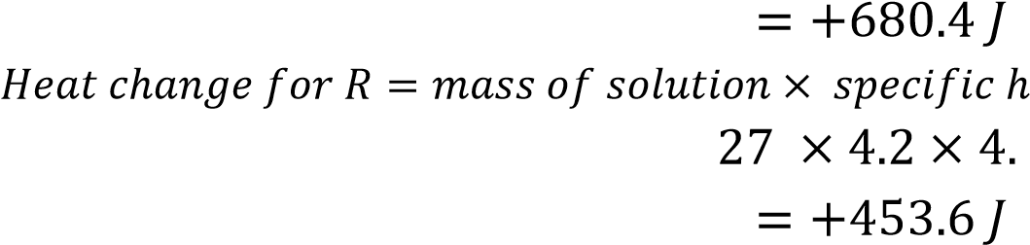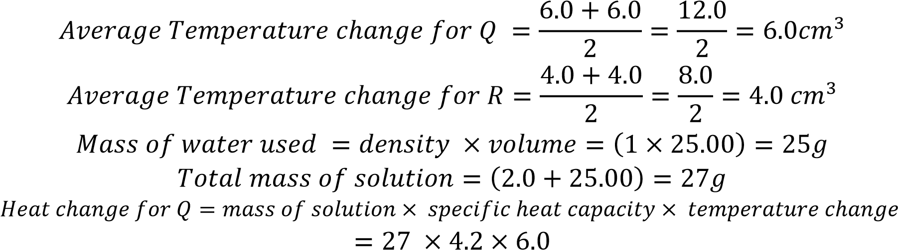

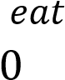

**Interpretation**: *Solid* ***Q*** *dissolves in water with a greater deduction in temperature and absorbs 680.4J which is greater than 453.5J absorbed when* ***X*** *is dissolved in water*

(b) What conclusions and recommendations can the school deduce from your findings?

**Conclusion and Recommendation:**

*Solid* ***Q*** *absorbs the highest amount of heat from the surrounding there fore it is recommended to be used by the team manager*

**ITEM 2**

During preparation of substances in industries, such as detergents, some raw materials are dissolved in water to form solutions.

An investor has found out new raw materials, ***Q,*** *and* ***X*** which are dissolved separately in water during the process of making detergents. During the process, some substances dissolve in water with absorption of heat from the surrounding, while others dissolve with evolution of heat to the surrounding

# Task

As a learner of chemistry,

i) Design an experiment you will carryout to help the investor make an informed decision about dissolution of the raw materials.

ii) Carryout the experiment and record your findings.

iii) What deduction can the investor draw from your findings?

|  |  |  |  |
| --- | --- | --- | --- |
|  | Basis of assessment | Assessment criteria | Scoring |
| i) | AIM OF THE EXPERIMENT | An experiment to investigate the heat changes that occur when substances Q, and X dissolve in water | 02 |
|  | Variables of the experiment | i)Dependent variable:  **Temperature change of the solution**  ii)independent variable:  **Different substances Q and X**  iii) controlled variables:  **Fixed volume of water**  **Fixed mass of substances Q and X used** | 03 |
|  | Hypothesis | Substances Q and X dissolve in water with evolution of heat or dissolve in water with absorption of heat | 02 |
|  | Materials used | Thermometer,  1 beakers,  electronic balance,  100cm3 measuring cylinder,  Distilled water  Thermometer  Solids Q and X | 03 |
|  | Procedures | a)50 cm3 of distilled water is measured using a measuring cylinder and is placed in a plastic beaker and its initial temperature noted  b) 2g of substance Q is measured using an electronic balance and added to plastic beaker and the mixture is stirred using a thermometer to dissolve and maximum or minimum temperature is noted  d) the change in temperature is determined from the formula; = final temperature – initial temperature  e) the above procedures are repeated for the other substance X | 04 |
|  | Risks and mitigation | Risk: Breakage of thermometer  Mitigation: Putting the thermometer in the case after use  Risk: solutions pouring on the skin or the question paper  Mitigation: put on lab coat, gloves, closed shoes | 02 |
| ii) | Presentation of data | |  |  |  |  | | --- | --- | --- | --- | | substance | Q | | | | Mass used(g) | 2.0 | 2.0 | 2.0 | | volume of water used (cm3) | 50 | 50 | 50 | | Initial temperature of water (oC) | 25 | 25 | 25 | | Final temperature of solution (oC) | 30 | 28 | 29 | | Change in temperature | 5 | 3 | 4 |  |  |  |  |  | | --- | --- | --- | --- | | substance | X | | | | Mass used(g) | 2.0 | 2.0 | 2.0 | | volume of water used (cm3) | 100.00 | 100.00 | 100.00 | | Initial temperature of water (oC) | 25.0 | 25.0 | 25.0 | | Final temperature of solution (oC) | 23.0 | 24.0 | 24.0 | | Change in temperature | 2 | 1 | 1 |   Interpretation of results  Assumptions: Density of solution ═ 1g/cm3  SHC of solution ═ 4.2oCg-1k-1  Quantity of heat evolved or absorbed  Heat loss or gain to/from the surrounding is negligible  Q:  H ═mc∆ϴ  Mass of solution ═ volume of water × density  ═ (50 × 1) g  ═ 50g  ∆ϴ ═ (5+4+3) /3  ═ 4 oC ( average change in temperature)  H ═ (50 × 4.2 x 4) J  ═  -1050J or – 1.05 kJ  X:  H ═mc∆ϴ  Mass of solution ═ volume of water × density  ═ (50 × 1) g  ═ 100g  ∆ϴ ═ 1+2+1  ═ 1.0  oC ( average change in temperature)  H ═ (100 × 4.2 x 5) J  ═ +420J or +0.42 kJ | 12 |
| iii) | Conclusion | Substance Q dissolves in water exothermically  Substance X dissolve in water endothermic ally | 02 |

CONFIDENTIAL

Substance Q: sodium hydroxide pellets / Anhydrous sodium carbonate

Substance X: ammonium chloride